**Certificate**

This is to certify that the following report titled "PaasPaasPASS", submitted by Bhumika Chopra - 2018MT10748, Priyanshi Gupta - 2018ME20707, Aditi Rai - 2018MT10736 in fulfilment of the academic requirements of the DISA Project 2019-20 represents bonafide work done under my supervision. It has not been submitted elsewhere to the best of my knowledge.

**Prof.Subrat Kar**

**Dept of Electrical Engineering &**

**Bharti School of Telecommunication Technology and Management**

**TABLE OF CONTENTS**

* **Aim**
* **Prior Ground Work**
* **Materials Used**
* **Project Description**
* **Working Explanation**
* **End Product**

**AIM**

The main need our project addresses is that of unavailability of seats in CSC during exam times. Often we decide to go to CSC in a group, to study but on reaching there we find that there are no seats available for all of us to sit together.

Our project tries to address this issue at a small scale, by assigning seats so that the maximum number of contiguous seats are available at all times. We hope to devise an algorithm which will allocate seats to the students as and when they come in a linear fashion i.e. we have numbered all the computers and the seat will be allocated starting from computer number 1 till the last computer per lab, taking their lab preferences into consideration. This concept may be extended into other areas of practical use as well such as (a) auditorium seating during event, crowd management, optimizing flat allocation during housing allotment etc (b) to allow prior booking of seats online with estimated time of usage (this will avoid the twin disappointments of (a) arriving and finding no seats available and (b) of wasting time).

**PRIOR GROUND WORK**

* Google form – conducted survey of requirements from users (students and other stakeholders),
* Effective pre-planning and algorithm design for allocation of seats by working on the basis of our algorithm,
* Implementation on a stand-alone system (not a PC).
* Our prior grond work gave us the motivation to continue with this project as many students were having trouble with this current system and wanted to see an improvement.

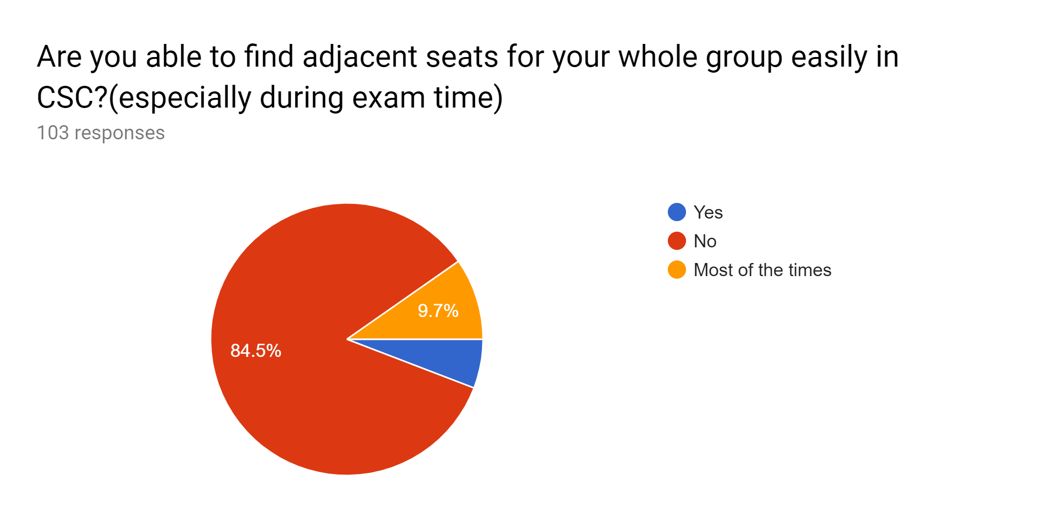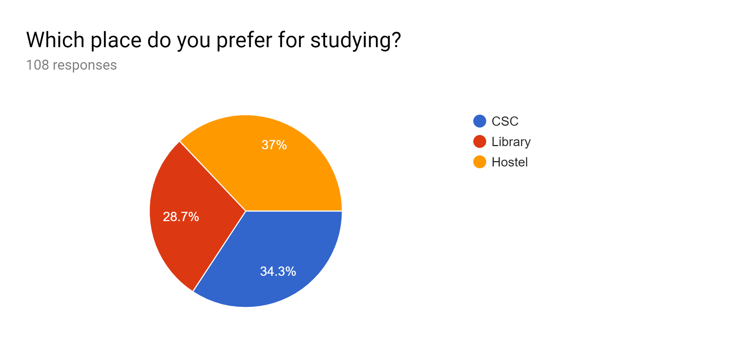

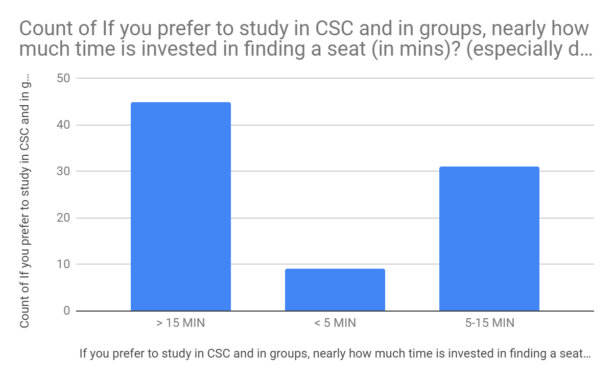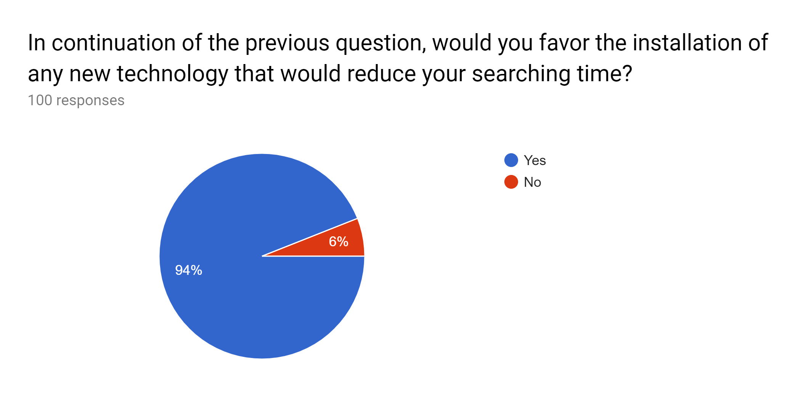

**MATERIALS USED**

| **Material** | **Price** |
| --- | --- |
| Display | 7,000.00 |
| Raspberry pi | 3,300.00 |
| SanDisk 16 GB Class 10 MicroSD 98MB/s (A1 Card) | 840 |
| SanDisk Cruzer Blade 16GB PenDrive | 1000 |
| Black And White Thermal Panel Printer | 2250 |
| Paper roll | 400 |
| Keyboard | 500 |
| Mouse | 300 |
| USB Adapter Charger for Raspberry | 220 |
| SD Card Reader | 155 |
| 3 pin power cable | 250 |
|  | 16,215.00 |

**PROJECT DESCRIPTION**

We worked with several models along the course of this project and came up with a final model which involved approval of all.

We worked in the Embedded Systems Lab throughout the course of the project under the supervision of Prof Subrat Kar. In the initial stages, we thought of a system in which we will ping all the systems from a central PC, situated outside CSC, connected on this network to check if it is used by a user and then update our database with that to ensure whether a student sits on the PC allocated to him/her. Then we took a few rounds at CSC to check the pinging system there. But pinging only checks if a PC is connected to the network or not, therefore for this method to work it required the students to switch off their PCs after leaving CSC, as told to us when we had discussions with the System Manager Sunil Kak Sir and other Technical Staff, which would lead to a lot of power wastage, hence was not feasible. Also, the systems in CSC had a DHCP server which required CSC to update our system every time which is a crucial matter for their security purpose, and hence we dropped with this model.

Then we thought about displaying the number of empty seats in every lab on our system which will be highly useful for a student in deciding which lab to choose and even to see if there are empty seats or not in CSC, especially during exam time when a considerable time of a student is wasted in searching for the right seat and sometimes the efforts go in vain if a student or a group of students are not able to find seats. All of this is backed by our ground work done in the form of google survey wherein students demanded a system to save their time. So, later we thought of incorporating this display of empty seats in our system. Prof Subrat Kar suggested us to incorporate the times when a lab is booked owing to several lab courses and exams. Hence, we added a feature wherein if a lab is being used for such purposes, then it can be booked. Also, when it is freed up, then it can be unbooked.

One very innovative element of our system is to save time for a student who’s trying to sign in or work on a faulty PC. So, after deliberately discussing this issue, we came up with a solution. All the failed systems will be listed in our database as faulty and will not be assigned to any student upon asking for allocation. We can also provide this list of PCs which are not working to CSC’s staff who can correct it. Also, if a student is allocated a PC which seems to be faulty, an additional feature that we have added will resolve this, where after entering the seat number, the system will be listed in our database as a faulty PC. And if the PC is corrected and starts working, an additional feature will remove it from our list of faulty PCs. This will ensure a smooth cycle of adding and removing a PC from the list.

We worked on the user interface part where we came up with an effective and modelled layout but that involved multiple screens. Prof Subrat Kar suggested us to avoid multiple screens because that would be very cumbersome and time-consuming for a student. So, we tried to arrange allocation and deallocation of seats, plus the lab input, all in one single screen. This makes it very easy for a student to get an understanding of the system and to avoid any confusion. The interface is very well structured and easy to use for anyone. We tried to make it simpler and simpler in every prototype of ours, so that the system achieves its peak of user friendliness.

For the coding part, we focused on learning how to create and modify files in python. Initially we had come up with a model which would only display the seat numbers on the screen after taking input of the number of seats required, but we figured that if the students did not have any concrete proof of their seat number then after entering CSC nobody was stopping them from going and sitting on some other seat. If a student went inside and sat on a different seat then it may lead to conflicts inside the lab. Hence, we finally after rigorous thought settled on a relatively simple solution to give the student a printed slip containing the seat number. Therefore, if a student enters the CSC to find someone else sitting in his/her assigned seat, then they can politely ask the other person to move.

The next important part of our project was studying about the materials and their connections. We invested a lot of time in understanding the different parts of the raspberry pi, operating system, printer and their connections to the 7” touch screen display. Prof Subrat Kar helped us throughout the course of the project and also gave us contacts to talk to the senior PhD students in understanding the functioning of various devices and softwares.

**WORKING EXPLANATION**

The prototype that we have developed will be placed on the guard’s desk, and will be accessible to him for operating purposes.

This is how the system will look like-

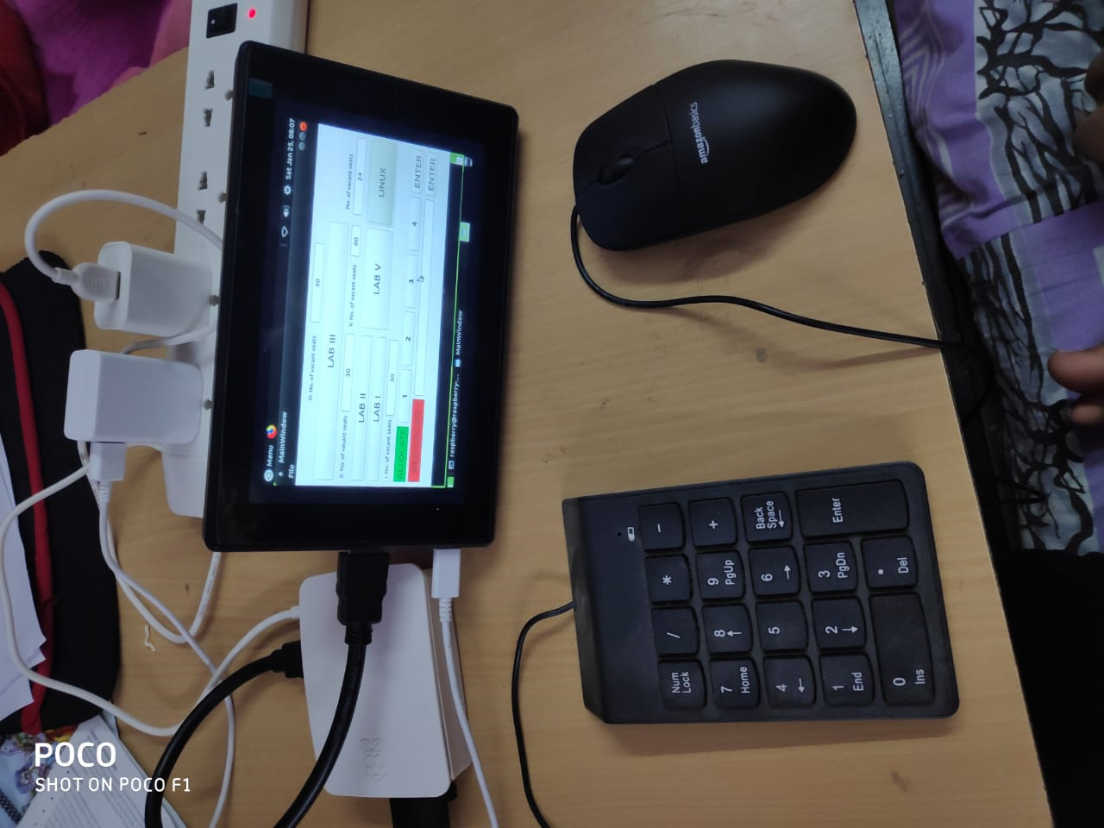

Here, we show the step-by-step method that one has to follow to get the desired number of seats, and then the way to deallocate them once leaving:

1. According to preference, one is given a choice to select the lab depending on the location one is comfortable sitting in. Suppose, Lab 1 is clicked.

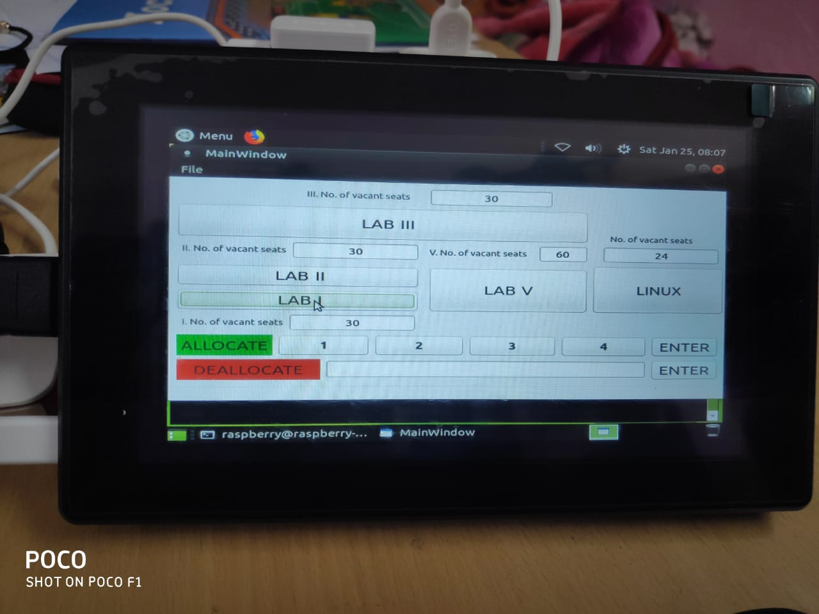

1. Then, one has to select the number of seats required in that particular lab. Suppose, we select 2.

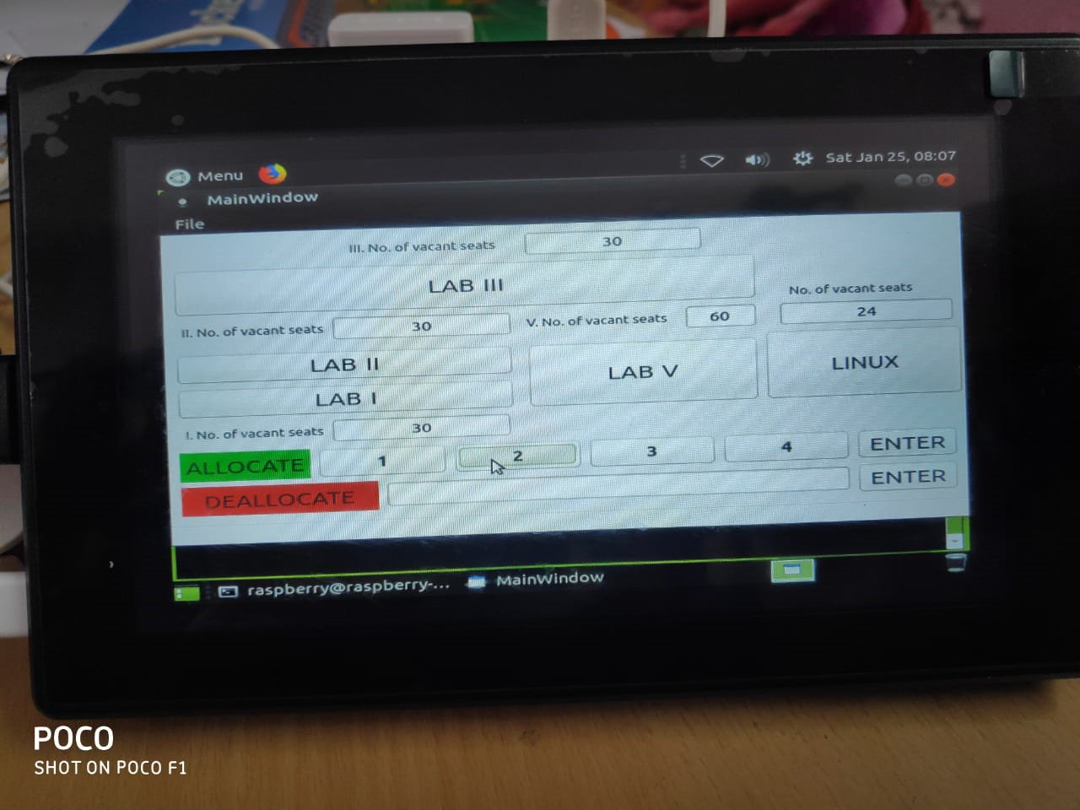

1. Then, the ENTER tab in line with the Allocate button has to be pressed. The seats displayed in front of Lab 1 will change to 28 in this case. Seat has been allocated now.

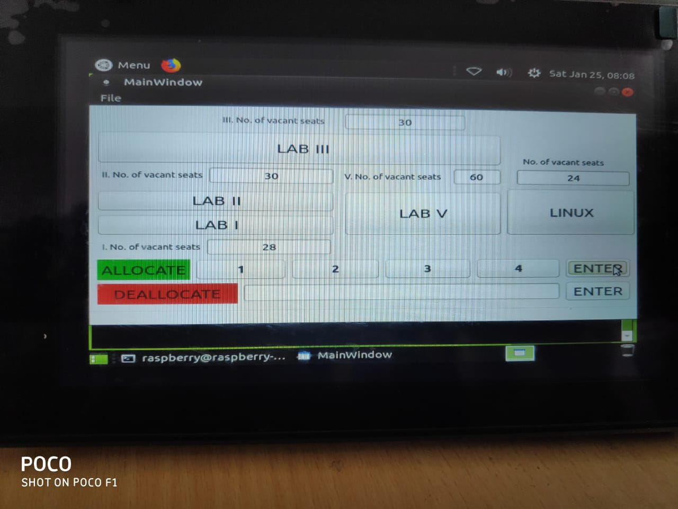

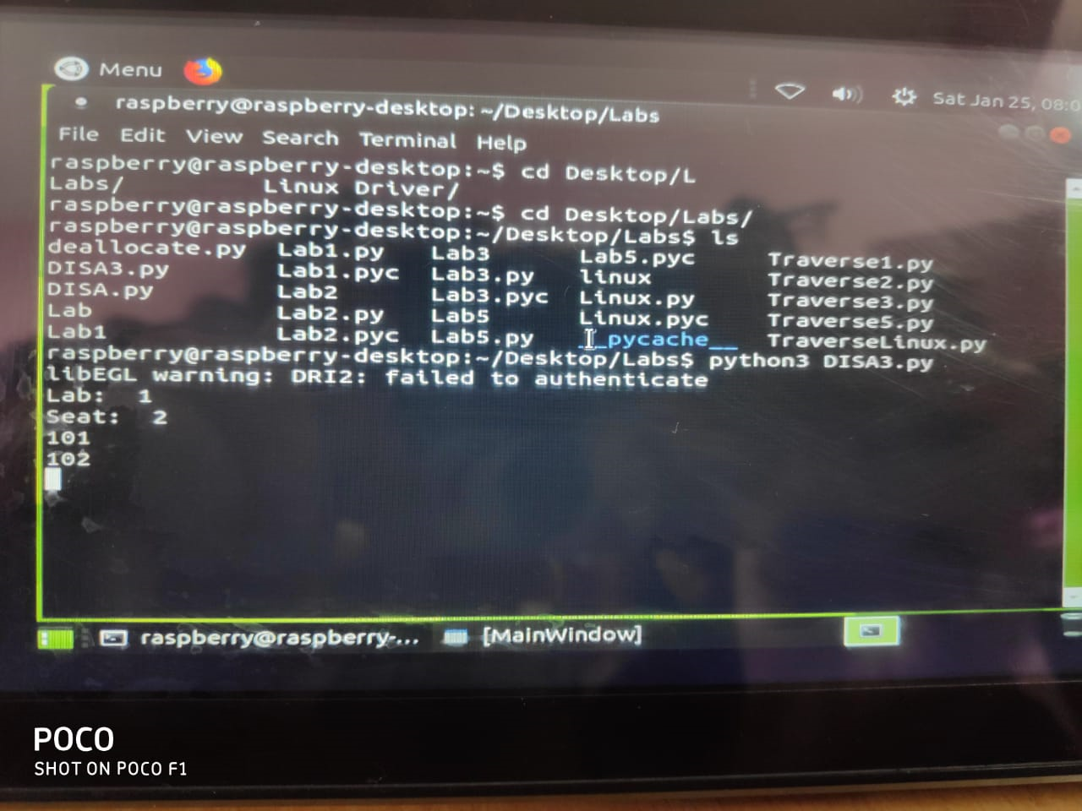

1. To deallocate the seats, the guard will enter the seat numbers told by students in Deallocate Seat Input Tab. Suppose, one enters 201, 202, 203 (with any delimiter for eg - ‘ ’, /, ‘,’, etc.). It’s understood that by 201, one refers to Lab 2 and Seat No 1.

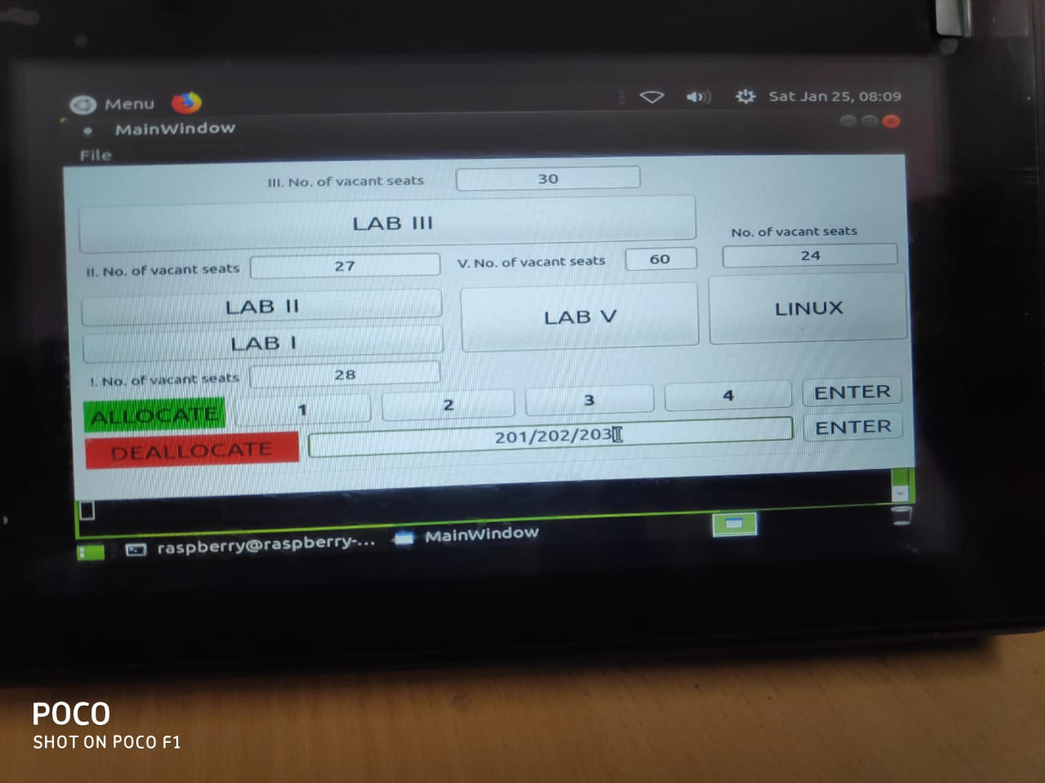

1. After pressing Enter, the seats (here, 201, 202, 203) will be deallocated. In our case, no of vacant seats for Lab 2 changed to 30 from 27, once they were freed.

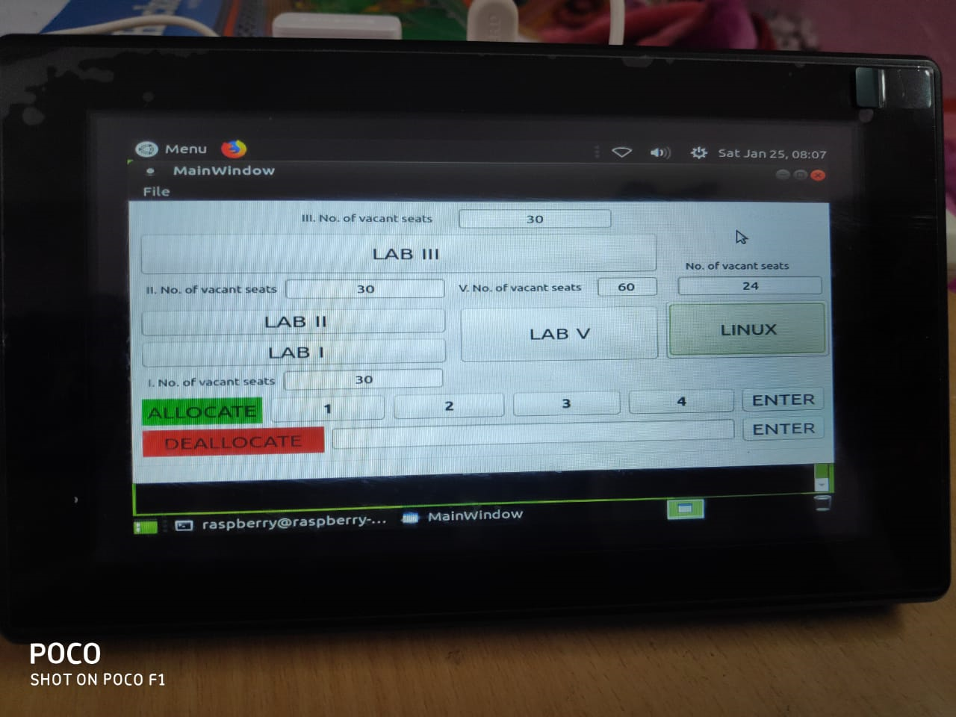

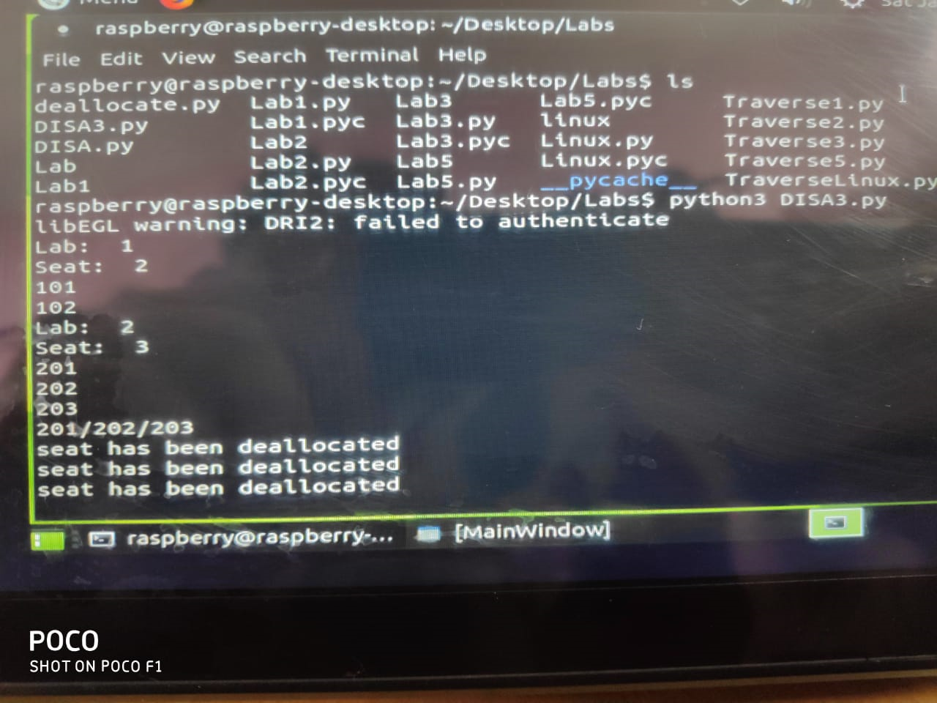

**END PRODUCT**

**Description of our final model**

* A person entering CSC will need to enter the number of seats required for seating purposes. The system will do a quick computation of the best suitable arrangement for the group of students.
* A SBC with a 7” touch screen, attached with a 40-col printer (thermal) placed in a see-through enclosure deployed on a pilot basis in CSC.

User interface will display lab numbers along with the vacant seats in each lab. Other buttons for allocation and deallocation of seats will also be there.

At first, students can choose the lab (as the number of vacant seats are displayed, students can choose accordingly)by clicking on it.

Next step is to select the number of seats required by the group. Students have to simply click on the allocate option on the same window, then select the number of seats (1/2/3/4), press Enter.

After completing the above procedure students will be provided with the printed slips containing the seat no.

An option of deallocation is also provided on the screen, this is basically to deallocate the PC once the user leaves it. User has to enter the seat numbers to be deallocated, and press Enter. The corresponding seat will be made available for the next user.

We worked on the efficiency of the algorithm by taking care to allot seats in a linear manner. By providing the count of available seats in each lab we ensured that less time is invested by the student to get the seat allocated. Thus we developed the algorithm, implemented it as a stand-alone system .

**THANK YOU**

**Submission by-**

**Aditi Rai (**2018MT10736)

**Bhumika Chopra (**2018MT10748)

**Priyanshi Gupta (**2018ME20707)